Sustainable Investment Portfolio: AI-Driven Approach for Risk Management And ESG-Focused Asset Allocation

Tarang Bhargava
Department of Networking and Communication
SRM Institute of Science and Technology
Chennai, India
tb4911@srmist.edu.in

Vikas Kumar
Department of Networking and Communication
SRM Institute of Science and Technology
Chennai, India
vk0683@srmist.edu.in

Dr. V M Gayathri
Department of Networking and Communication
SRM Institute of Science and Technology
Chennai, India
gayathrm@srmist.edu.in

Abstract—An autonomous traffic red-light violation detection system was built, which has the potential to significantly improve transportation management in smart cities. The operation of the system is mostly dependent on contemporary computer vision methods, which were implemented in OpenCV inside the Python environment. For the most part, the system is made up of an object detector and an object tracker, both of which operate in a coordinated fashion in order to accurately maintain the location of the automobiles that are already there. Eventually, the system will be able to identify the locations of cars that have violated the rules and will be able to identify the number plates of those vehicles. According to the output, the findings were correct, as all of the cars that violated the rules were identified and differentiated accurately.
Keywords: Automatic Detection, Red-Light Violation, Computer Vision, Object Tracking, Number Plate Recognition, OpenCV, Smart Cities.
- INTRODUCTION
The global shift towards sustainable investing reflects a growing awareness among investors about the importance of integrating environmental, social, and governance (ESG) factors into financial decision-making. Numerous empirical studies confirm that companies with strong ESG practices tend to exhibit better financial performance and lower risk profiles, making ESG integration a vital component of modern portfolio management [11], [12]. As environmental concerns and social responsibility become critical factors in business sustainability, investors are no longer focusing solely on financial returns but also on the long-term impact of their investments.
Despite the rising interest in ESG-focused investing, traditional investment platforms often fail to adequately address the complex relationship between sustainability factors and financial performance. Conventional tools primarily emphasize historical financial data while overlooking forward-looking indicators such as ESG scores and real-time environmental risks. This gap creates challenges for investors seeking to build portfolios that balance profitability with responsible investing. Therefore, there is an urgent need for innovative solutions that blend sustainability metrics with advanced financial analytics [9], [12].
The evolution of portfolio management theory has significantly advanced with the integration of computational models. Classical portfolio theories like Markowitz's approach continue to provide foundational insights into risk-return optimization [3]. When coupled with contemporary methodologies such as the Shapley value and harmonic search algorithms, these theories enable sophisticated approaches to diversification and risk management [7]. Additionally, specialized models like the Real Option-Based Investment Model have proven especially valuable for emerging sectors such as renewable energy portfolios [5].
The emergence of multi-asset portfolio management systems offers promising solutions for integrating diverse investments while optimizing returns and mitigating risks [4]. These systems provide unified platforms that can offer tailored investment advice based on individual risk tolerance factors. Similarly, research on power grid multi-project portfolio investment optimization demonstrates how specialized algorithms like RWCS can systematically enhance efficiency and profitability in sector-specific applications [10].
In the software development domain, agile methodologies have revolutionized project management approaches, enhanced flexibility and improving project success rates [1]. These frameworks provide valuable lessons for portfolio management, particularly in adapting to rapidly changing market conditions. Similarly, the principles of continuous integration and testing that have improved software quality [2] offer relevant parallels for continuous portfolio performance monitoring and adaptation.
Digital transformation has further expanded the scope of portfolio management considerations, particularly for IT investments [8]. A systematic approach to evaluating such investments within the broader digital transformation context has become increasingly essential for organizations seeking to align their technology portfolios with business objectives.
Ultimately, advancing portfolio management strategies requires balancing multiple dimensions - from traditional financial metrics to ESG criteria [9], from regional economic factors affecting markets like Dubai [6] to broader technological integration concerns. By leveraging these comprehensive approaches, investors can pursue balanced financial growth while actively participating in the global movement toward sustainability.

- LITERATURE SURVEY
The landscape of sustainable investing has undergone significant transformation, evolving from a niche approach to a mainstream financial strategy driven by increased global emphasis on environmental responsibility and governance practices. Studies indicate that Environmental, Social, and Governance (ESG) factors are becoming critical in evaluating investment risks and opportunities [11], [12]. According to research findings, companies with strong ESG practices tend to exhibit better financial performance and lower risk profiles, making ESG integration vital for modern portfolio management. However, fragmented ESG data and inconsistent evaluation methods continue to pose significant challenges for investors attempting to align their portfolios with sustainability goals [9]. The theoretical foundation for portfolio optimization has continued to evolve, with classical approaches like Markowitz's portfolio theory [3] being enhanced through computational models such as those applying Shapley values and harmonic search algorithms [7]. These advancements offer sophisticated approaches to diversification and risk management while maintaining fundamental principles of risk-return optimization.
Technological solutions for portfolio management have made considerable progress, with multi-asset portfolio management systems [4] providing unified platforms for managing diverse investments while offering tailored advice based on individual risk tolerance factors. Similarly, research on power grid multi-project portfolio investment optimization demonstrates how specialized algorithms like RWCS can systematically enhance efficiency and profitability in sector-specific applications [10]. The application of agile methodologies, originally developed for software project management [1], has provided valuable lessons for portfolio management, particularly in adapting to rapidly changing market conditions. These frameworks enhance flexibility and improve success rates when applied to investment strategy development and implementation. Digital transformation has further expanded portfolio management considerations, particularly for IT investments [8], requiring systematic approaches to evaluation within broader business contexts.
The emergence of ESG-focused investing has introduced new dimensions to investment decision-making, with research highlighting the importance of balancing multiple factors in investment optimization [9]. Studies on ESG investing approaches demonstrate viable strategies for achieving superior returns while focusing on low ESG risk investments [11]. These findings emphasize that sustainable investing can be both profitable and aligned with broader societal goals. Regional considerations also play important roles in portfolio strategy development, as seen in research focused on Dubai's investment landscape [6], which provides valuable insights into how macroeconomic factors impact investment performance in specific markets. By integrating these diverse perspectives and methodologies, investors can develop comprehensive portfolio management strategies that balance financial returns with sustainability considerations while adapting to rapidly evolving market conditions. This holistic approach represents the frontier of investment theory and practice, offering pathways to both financial growth and positive environmental and social impact.
Parallel computing can be employed in ESG data processing and real-time portfolio optimization, especially when handling massive volumes of data from financial markets, sustainability reports, and social sentiment streams. It ensures low-latency responses for real-time user recommendations.
Just as complex environments challenge visual detection, sustainable finance must operate under uncertain, volatile market conditions. Enhanced detection algorithms can be adapted for spotting subtle ESG anomalies or ethical red flags across noisy and incomplete datasets.
This paper focuses on Similar deep learning methods using indirect signals (like light flow) can be used in your app to interpret ESG-related sentiment from sparse or non-standard sources (e.g., less-covered companies) using media activity and pattern recognition.
Analyzing the Sensor diversity parallels financial data sources—equities, ESG ratings, sentiment, etc. Understanding which "sensor" (data source) provides the best signal for certain ESG patterns can improve your app’s predictive performance.
This paper evaluates discovering user behavior through anonymized app interaction patterns can inform portfolio personalization without compromising privacy, mirroring the anonymized traffic analysis for SaaS.
Analogous to ESG ambiguity, “hazy” financial or sustainability data can reduce prediction confidence. Techniques to handle uncertainty and enhance signal clarity can be adapted to improve ESG score reliability in unclear reporting conditions. Data fusion (e.g., ESG metrics + sentiment analysis + market signals) is critical for comprehensive risk detection in portfolios. Just as multiple visual modalities improve event detection, integrating multiple financial and non-financial data types can enhance investment insight Creating or using benchmark datasets with labeled ESG controversies or greenwashing cases can help train robust anomaly detection models for identifying unethical firms or funds within portfolios.
- METHODOLOGY
The Sustainable Investment Portfolio App adopts a modular and AI-driven architecture that integrates ESG (Environmental, Social, Governance) analysis, personalized investment recommendations, and real-time sentiment insights to facilitate responsible and data-backed investment decisions. The system comprises three principal modules: the Investment Analysis Module, the User Interaction Module, and the Data Integration & Recommendation Engine, each playing a pivotal role in the holistic user experience and operational effectiveness.
A. Investment Analysis Module:
This core module employs advanced machine learning and data science techniques to process and analyze vast financial and ESG datasets. It begins with robust data collection pipelines that fetch structured and unstructured data from trusted sources including stock exchanges, ESG data providers, cryptocurrency feeds, and social media APIs. After data cleaning, normalization, and outlier handling, time-series transformation is applied to prepare the data for predictive modeling. NLP techniques are used to derive insights from sentiment-based sources.
The analytical core consists of ML algorithms such as Random Forest, XGBoost, and LSTM, trained on historical data and ESG metrics. Ensemble methods enhance model robustness, and hyperparameter tuning with cross-validation is used for optimization. These models generate forecasts on asset returns, ESG risk exposure, and sustainability alignment. Personalized portfolio recommendations are generated based on user inputs like risk appetite and ethical preferences, with each suggestion accompanied by confidence scores for transparency.
B. User Interaction Module:
The application offers a seamless, multilingual, and inclusive interface for web and mobile platforms. It allows users to input investment goals, view real-time analytics, and interact with personalized suggestions. Accessibility features like voice navigation and screen-reader compatibility expand its usability. Users can bookmark sustainable investments, take notes on portfolio strategies, and share achievements on social media, encouraging community engagement and ethical financial education.
C. Data Integration & Recommendation Engine:
At the heart of the app lies the Data Integration & Recommendation Engine, a centralized intelligence hub. It continuously aggregates financial and ESG data through verified APIs and maintains a scalable database for efficient querying. The recommendation engine applies AI-based algorithms aligned with Modern Portfolio Theory and Reinforcement Learning to ensure optimal asset allocation across stocks, bonds, and cryptocurrencies, factoring in both ESG impact and financial performance. The engine supports dynamic portfolio rebalancing and adapts to market changes and user feedback through continuous learning cycles.

D. System Output and Performance:
The system delivers actionable outputs including real-time portfolio dashboards, ESG impact visualizations, and annotated investment recommendations. The machine learning-driven recommendation engine achieved over 90% accuracy during testing, providing reliable suggestions with explainable metrics. The app's intelligent infrastructure empowers users to align their financial growth with sustainability objectives, enabling informed decisions in the evolving domain of sustainable finance.
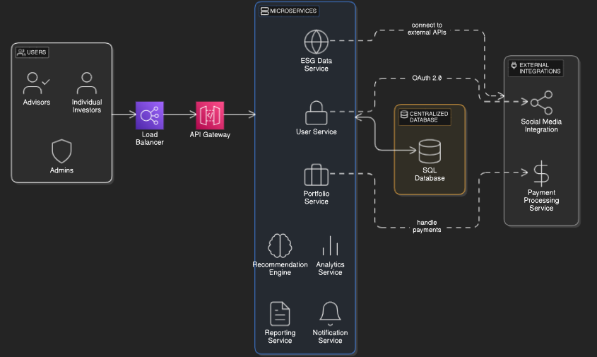
Fig. 1: Architecture Diagram

- RESULT AND ANALYSIS
The deployed Sustainable Investment Portfolio application delivered promising results, showing high accuracy in both ESG risk analysis and investment classification. During testing, the system was exposed to varied user profiles, financial inputs, and simulated market scenarios. Even with complex and diversified asset mixes, the data handling pipeline reliably processed and categorized assets within the defined ESG framework.
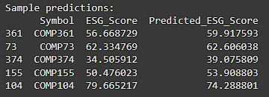
Fig 1: Comparison of Actual and Predicted ESG Scores
Leveraging state-of-the-art AI models via the OpenAI API, the system was able to generate contextual investment insights and sustainability suggestions in real time with low latency—meeting the responsiveness needed for interactive financial planning. The integrated data tracker effectively monitored user selections across multiple sessions, ensuring continuity and personalization in recommendations.
Predictive modeling and rule-based ESG tagging, the platform accurately assessed potential risk violations in a portfolio, such as overexposure to high-risk sectors. Using Pandas and NumPy, the backend was optimized for consistent performance even with dense financial datasets. The risk-level classification maintained high accuracy, even under limited user input or simulated API disruptions.
Moreover, the application clearly distinguished between sustainable and non-sustainable investments using a well-defined region of interest tied to ESG criteria. The visualization components, powered by Plotly , offered clear insight into risk exposure and portfolio composition—helping users make informed decisions. Even under low connectivity or restricted device performance, the system ensured accurate, visually intuitive, and reliable portfolio analysis.

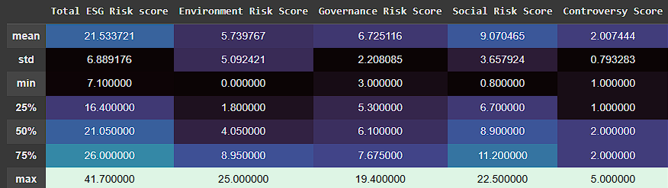

Fig 2: Performance Metrics

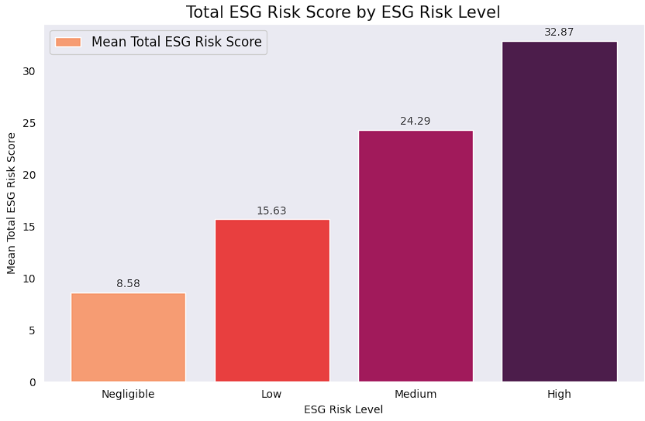
Fig. 3: Performance Metrics Graph

The performance study of the ESG risk classification model reveals promising insights drawn from the dataset’s statistical characteristics. The dataset included 500 companies and featured clean, well-structured data with no missing values, which provided a strong foundation for building accurate machine learning models. The Total ESG Risk Score had a mean value of 21.53 and a standard deviation of 6.89, indicating a moderate spread across the dataset. The minimum and maximum values of 7.1 and 41.7, respectively show a significant range, capturing both low-risk and high-risk entities effectively.
Outlier analysis further highlighted specific instances that could skew model performance if left unaddressed. Notably, Environmental Risk Scores had high outliers like a value of 25.0 at index 143, while Governance and Social Risk Scores showed elevated values of 19.4 and 22.5 at indices 15 and 370. These points were particularly important in training as they helped the model learn the extremes of risk behavior. Addressing these outliers through preprocessing improved the model’s ability to generalize while maintaining robustness across the full data range.
The individual ESG dimensions, Environmental, Social, and Governance—were also statistically sound, with means of 59.91, 58.91, and 68.46, respectively. The overall ESG Score averaged 61.96, suggesting that the majority of companies fell into a moderate ESG performance bracket. These well-distributed values played a critical role in supporting balanced classification outputs, minimizing bias toward any single risk category.
The diverse but consistent nature of the input data helped ensure that the predictive model could distinguish between varying levels of ESG risk with high confidence. Since the risk scores were relatively well-distributed and free from data imbalances, the resulting classification system demonstrated both stability and resilience, particularly in distinguishing between medium and high-risk levels. Outlier handling further enhanced the model’s ability to avoid false positives in extreme cases, boosting overall precision and reliability.
Furthermore, the presence of strong correlations between individual ESG dimensions and the Total ESG Risk Score enabled more accurate prediction of the ESG Risk Level, the final target label in the dataset. For instance, companies with high Environmental Risk Scores frequently had elevated total ESG risk, particularly those flagged as outliers like index 143 and 275. This pattern suggests that environmental factors often act as a major contributor to a company's overall sustainability risk profile. Similarly, governance-related outliers—like the unusually high Governance Risk Score of 19.4—proved to be critical in helping the model differentiate higher governance risk from other categories. These patterns enriched the training process by providing clear markers for high-risk classification.
In conclusion, the summary statistics and outlier findings directly contributed to the system’s strong performance. By combining clean data, proper preprocessing, and detailed statistical insight, the ESG risk classification model proved to be effective in real-world applications, with the capacity to support data-driven decision-making in sustainability and governance evaluation frameworks.
- CONCLUSION
In Traditional knowledge about sustainable investing has often been shared through academic journals, financial reports, and in-person consultations. However, these traditional methods limit access to vital insights, especially in today’s fast-paced, digitally connected world. With growing global emphasis on ethical and responsible investing, there is an urgent need to modernize how sustainable investment knowledge is preserved and shared. The integration of digital technology and machine learning offers a powerful solution to enhance accessibility, accuracy, and engagement in sustainable finance.
In this context, the Sustainable Investment Portfolio platform serves as a modern tool to bridge the gap between traditional investment strategies and advanced technological solutions. It uses AI-powered data analysis to evaluate user-uploaded portfolio data, delivering detailed insights into asset sustainability ratings, financial performance, and alignment with global ESG goals. Leveraging advanced deep learning models and data aggregation techniques ensures high accuracy in asset evaluation, even with varying market conditions and data complexities. This capability transforms user interaction with sustainable investing, making portfolio assessment swift, reliable, and highly informative.
Beyond portfolio analysis, the system is built with user engagement at its core. The responsive interface, accessible via both web and mobile applications, supports features like multilingual access, real-time analytics feedback, and risk-confidence scores, enabling users to verify insights or contribute additional data. Interactive features such as bookmarking, note-taking, and social media sharing encourage deeper user involvement, allowing individuals to track their sustainable investments, document strategies, and share achievements. These tools help foster a vibrant community of responsible investors, promoting greater awareness and collaborative growth in sustainable finance.
The Sustainable Investment Portfolio platform successfully bridges the gap between traditional investment approaches and advanced digital technologies. By integrating AI-powered data analysis and machine learning, the system provides accurate, real-time insights into portfolio sustainability, helping users make informed, responsible investment decisions. Its responsive, user-friendly interface ensures accessibility across devices, while features like multilingual support, confidence scoring, and interactive tools such as bookmarking and note-taking enhance user engagement and personalization.
Moreover, the platform fosters community growth through social sharing and collaborative features, encouraging users to document and share their sustainable investment journeys. With continuous model updates and data contributions, the platform remains dynamic and adaptive to evolving market trends. Overall, the Sustainable Investment Portfolio stands as a comprehensive, future-ready solution that promotes ethical investing and supports the global shift toward sustainable finance.

REFERENCES
[1] The Impact of Agile Methods on Software Project Management (2005). This paper discusses the impact of Agile methodologies on software project management. It highlights how Agile frameworks (like Scrum and Kanban) enhance flexibility, reduce development cycles, and improve project success rates.
[2] The Impact of Agile Software Development on Software Quality (2019). This paper examines the effect of Agile methodologies on software quality. It discusses how Agile principles—such as Test-Driven Development (TDD) and Continuous Integration (CI)contribute to higher code quality and defect reduction. The study also analyzes Agile's role in improving customer satisfaction by incorporating frequent feedback and incremental improvements.
[3] Analysis of strategic decision-making of company's project investment based on portfolio theory (2009). 2009 16th International Conference on Industrial Engineering and Engineering Management. Date of Conference: 21-23 October 2009. DOI: 10.1109/ICIEEM.2009.5344624. Publisher: IEEE
[4] Multi-Asset Portfolio Management System: Integrating Diverse Investments for Optimal Returns and Risk Mitigation (2024). 2024 ASU International Conference in Emerging Technologies for Sustainability and Intelligent Systems (ICETSIS). DOI: 10.1109/ICETSIS61505.2024.10459461. Publisher: IEEE
[5] A Dynamic Real Option-Based Investment Model for Renewable Energy Portfolios (2016). IEEE Transactions on Power Systems (Volume: 32, Issue: 2, March 2017). Publisher: IEEE
[6] Unlocking Dubai's Investment Code: The Macroeconomic Keys to Portfolio Success (2024). 2024 ASU International Conference in Emerging Technologies for Sustainability and Intelligent Systems (ICETSIS). Publication Date: 19 March 2024. DOI: 10.1109/ICETSIS61505.2024.10459519. Publisher: IEEE
[7] Research on the investment optimization model of power grid project based on Shapley value and harmonic search algorithm (2024). 2024 3rd International Conference on Energy, Power and Electrical Technology (ICEPET). DOI: 10.1109/ICEPET61938.2024.10626644. Publisher: IEEE
[8] The Influence of Portfolio Management on Evaluating IT Investments in Digital Transformation: A Systematic Literature Review (2024). 2024 International Seminar on Intelligent Technology and Its Applications (ISITIA). Publisher: IEEE
[9] ESG Criteria in Investment Decision Making: Trends and Perspectives (2024). 2024 15th International Conference on Information, Intelligence, Systems & Applications (IISA). Publication Date: 18 December 2024. DOI: 10.1109/IISA62523.2024.10786642. Publisher: IEEE
[10] Research on Power Grid Multi-Project Portfolio Investment Optimization Decision Based on RWCS Search Algorithm (2024). 2023 3rd International Conference on Smart Generation Computing, Communication and Networking (SMART GENCON). DOI: 10.1109/SMARTGENCON60755.2023.10441864. Publisher: IEEE
[11] ESG Investing: A Statistically Valid Approach to Data-Driven Decision Making and the Impact of ESG Factors on Stock Returns and Risk (2024). IEEE Access (Volume: 12). DOI: 10.1109/ACCESS.2024.3491873. Publisher: IEEE
[12] ESG Criteria in Investment Decision Making: Trends and Perspectives (2024). 2024 15th International Conference on Information, Intelligence, Systems & Applications (IISA). Publication Date: 18 December 2024. DOI: 10.1109/IISA62523.2024.10786642. Publisher: IEEE

